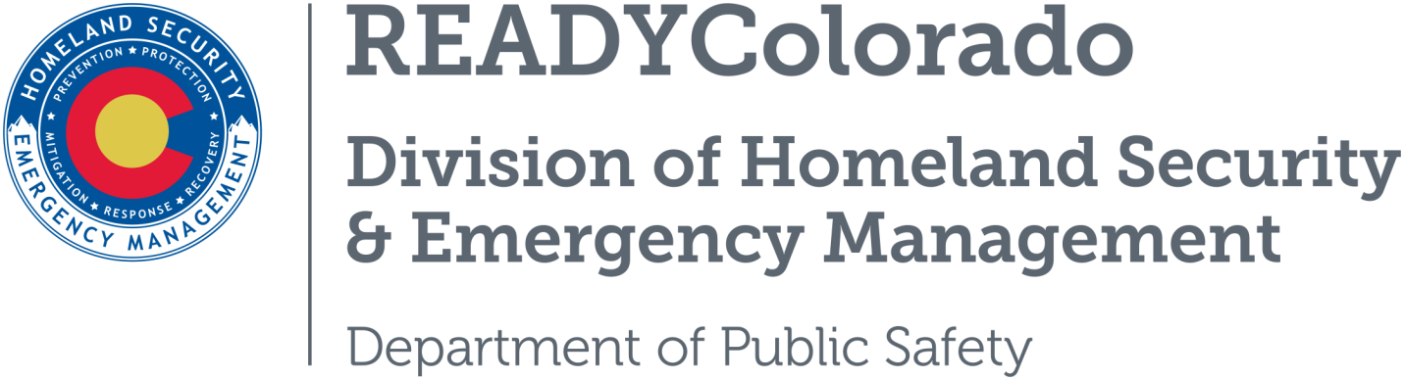
Spread the word with daily online safety and preparedness tips on Google+, Facebook and Twitter. Use the following blog, or create your own, and post all throughout the month. Remember to include the hashtags #COReady and #IDTheft

Title: Love is in the Air and so are the Scams—guest blog by the Colorado Bureau of Investigation, ID Theft & Fraud Unit

Romance scams affect thousands of people every year, but many victims do not believe they are victims and continue sending money. The average loss per person is about $9,000-$10,000 and some have lost as much as $500,000, have mortgaged homes, sold vehicles, pawned family heirlooms, and taken out loans to send money.
Following a few simple steps can help reduce your risk of being scammed by a con artist Casanova.
- Do not trust someone you meet online just because you meet on a faith based or special interest website. Scammers will fake their faith to win your trust.
- Be suspicious if a new love interest suggests leaving the website and chatting by email or instant messages.
- Question “love at first sight” proclamations.
- Be cautious if a new love interest claims to be a US citizen living or working in another country.
- Never wire money to someone who you have no met, even if he or she claims to be the love of your life.
- Be wary of hard luck stories that can be remedied by you sending money.
- Do not forget that you do not know the person you are talking with online. That picture he or she sent could be a fake.
- Do not send money for travel so your love interest can meet you face to face. Chances are you will never see your money again.
- Do not send money as a loan.
- Do not send money to anyone you have no met and do not know.
- Be suspicious if stories change or become more desperate.
- Do not try to contact your new love interest if he or she stops contacting you after you send money.
- Report and suspicious activity to law enforcement.
- Don’t let the scam artists break your heart and your bank account!
Learn more about reporting and staying safe from scams by contacting the Colorado Bureau of Investigation Victim Advocate at (303) 239-4649 or by emailing CBI.StopIDTheft@state.co.us. You can also call the 24 hour Identity Theft and Fraud Hotline at (855) 443-3489.
Source: Colorado Bureau of Investigation—Identity Theft and Fraud Unit
For more tips and preparedness information, follow us:
On Twitter: @READYColorado
Facebook: www.Facebook.com/READYColorado
Google +: READYColorado
YouTube: www.YouTube.com/READYColorado

