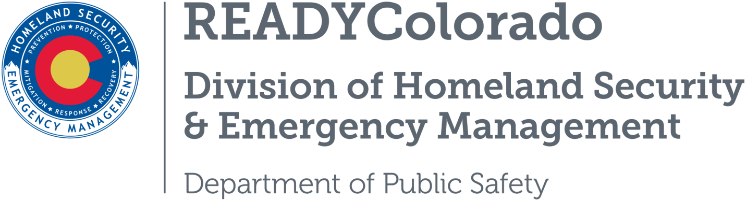
Spread the word with daily online safety and preparedness tips on Google+, Facebook and Twitter. Use the following blog, or create your own, and post all throughout the month. Remember to include the hashtags #COReady #PreventPoison #NPPW2017

Title: National Poison Prevention Week
March 19-25, 2017 is National Poison Prevention Week! Poisoning is the leading cause of death from injuries in the United States, as reported by the Centers for Disease Control and Prevention, National Center for Health Statistics. Each year, more than two million poisonings are reported to the nation’s poison centers, which can be reached through the toll-free Poison Help line, 1-800-222-1222.
The following tips can help protect you and your loved ones:

Safety Tips
- Use National Poison Prevention Week as a time to inspect your entire home for any medicines or household products, such as detergents, cleaning products, pesticides, and fertilizers that may not be stored properly. Always store medicines and household products up high.
- Keep the toll-free Poison Help number, 1-800-222-1222, near your phone, or program it into your home and mobile phone.
- When you leave your children in a babysitter’s care, ensure he/she also knows about the Poison Help number (1-800-222-1222).
- Install safety latches on cabinets used for medicines and household products.
- Keep medicines and vitamins in cupboards that are out of reach of children.
- Never call medicine “candy” to get a child to take it.
- For older members of the family who may be struggling to read the small type on medicine labels, use a daily dosage reminder dispenser to help track date, time and dosage.
- Never take more than the prescribed amount of medicine.
- Tell your doctor what other medicines you are taking so you can avoid harmful or dangerous drug interactions. This includes prescriptions, over-the-counter medicine, vitamins and herbal supplements.
- Clean out medicine cabinet periodically, and safely dispose of medicines that are expired or no longer needed.
- Never share or sell your prescription medicines.
- Support the Colorado initiative to Take Meds Seriously
- Visit American Association of Poison Control Centers which supports the nation’s 55 poison centers on their efforts to prevent and treat poison exposures. They offer free, confidential medical advice 24 hours a day, seven days a week through the Poison Help line at 1-800-222-1222.

Source: Poison Prevention Week Council
For more tips and preparedness information, follow us:
On Twitter: @READYColorado
Facebook: www.Facebook.com/READYColorado
Google +: READYColorado
YouTube: www.YouTube.com/READYColorado

