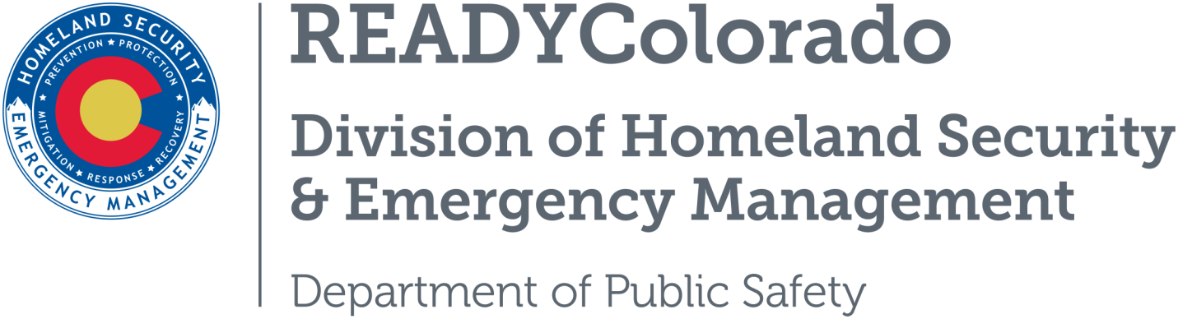
Spread the word with daily online safety and preparedness tips on Google+, Facebook and Twitter. Use the following blog, or create your own, and post all throughout the month. Remember to include the hashtags #COReady #NCSAM #CyberAware

Protecting Critical Infrastructure from Cyber Threats
The essential systems that support our daily lives – such as electricity, financial institutions and transportation – are all dependent upon the internet. Building resilience in critical infrastructure is crucial to our national security. This last week of National Cybersecurity Awareness Month (NCSAM) will look at cybersecurity in relation to keeping our traffic lights, running water, phone lines and other critical infrastructure secure. It also facilitates the transition to November’s Critical Infrastructure Security and Resilience Month (CISR), highlighting the tie between cybersecurity and our nation’s critical infrastructure.

How You Can Help
Our everyday activities – like taking showers, watching televisions, driving cars and using computers and smart phones – all depend on utility infrastructure, including electricity, gasoline, water and telecommunications systems. These essential systems now run on digital networks which mean they are vulnerable to cyberattacks. It is more important than ever for all segments of the community to understand cyber threats and be safer and more secure online. Individuals can help keep critical infrastructure safe by practicing good cyber habits and by encouraging their utility companies to adhere to high cybersecurity standards.

Protecting our critical infrastructure means that our homes and businesses will have power, our transportation systems will take us where we need to go, and our communications systems will help us connect at work and at home. You can play a part in securing America’s critical infrastructure in the following ways:
- Read the privacy policy of a company or vendor and check out online reviews before purchasing a product or service.
- Make sure websites that ask for personal information (to pay a utility bill, for example) use encryption to secure their sites.
- Learn about steps to enhance security and resilience in local businesses and communities, and how to handle certain events.
- If you run a business, make a plan to protect your organization’s information from cyber threats.
- Report suspicious activity

The systems that give us more freedom and enhance our daily lives are all dependent upon a delicate digital ecosystem. As cyber breaches continue to rise in frequency and scale, it is critical for all Americans to understand their role and take steps to protect our critical infrastructure. To receive cybersecurity tips year round, visit www.dhs.gov/stopthinkconnect and become a friend of the Stop.Think.Connect. Campaign.

Resources
- Department of Homeland Security
- Stop.Think.Connect
For more tips and preparedness information, follow us:
On Twitter: @READYColorado
Facebook: www.Facebook.com/READYColorado
Google +: READYColorado
YouTube: www.youtube.com/READYColorado

