Colorado Emergency Planning Commission

Annual Report
2011
March 1, 2012
Pr
The Colorado Emergency Planning Commission (CEPC) was created to carry out duties as required under SARA Title III and the Emergency Planning and Community Right-to-Know (EPCRA) provisions. This law was passed by Congress in 1986 to help ensure that state and local governments are prepared to respond to chemical accidents. (for more information on the purpose and duties of the CEPC please visit our website: http://www.coloradoepc.org/

Colorado Emergency Planning Commission

Commission Members
The Commission is made up of the following members:
Greg Stasinos - CEPC Co-Chair  Department of Public Health  and Environment * | Dave Hard - CEPC Co-Chair  Department of Local Affairs  Division of Emergency Management *
Theresa Staples  Department of Public Safety  Division of Fire Safety * | Barry Cress  Department of Local Affairs  Division of Local Government *
Steve Riner  Affected Industry  Black Hills Corporation | Don Sherman  Affected Industry  AECOM Environment
Steven Boand  County Commissioner  Douglas County | Wally White  County Commissioner  La Plata County
Matt Packard  Department of Public Safety  Colorado State Patrol * | Patricia Williams  Emergency Management  Denver LEPC
Roy Rudisill  Emergency Management  Weld County LEPC | Rose Lynch  Public Interest
*Indicates a statutorily required member organization. The balance of the CEPC is made up of representatives appointed by the Governor each serving a two (2) year term.
The commission meets bi-monthly and has formed subcommittees to work on specific tasks. All meetings are posted and open to the public.
Meetings generally include standing reports regarding:

- Legislative issues
- Homeland security working group
- HMEP grant status
- Annual conference planning update

Year in Review

Hazardous Material Emergency Planning Grant

The Hazardous Materials Emergency Preparedness (HMEP) grant program provides financial assistance to enhance hazardous materials emergency planning and training to emergency responders and Local Emergency Planning Committees.

Local Emergency Planning Committee (LEPC) Conference
The CEPC hosts an annual conference for Local Emergency Planning Committees. This year’s conference was held September 7, 8, and 9th, 2011 in Breckenridge, Colorado and included an optional half day workshop entitled LEPC 101which focused on educating new LEPC members.
106 participants attended the conference including 60 who attended the LEPC 101 session. Attendees included representatives from local, state, and federal partners as well as representatives from the private sector.
Conference topics included presentations on EPA updates, Department of Homeland Security regulations, Civil Support Team capabilities, State Hazmat Working Group updates, and Safety Performance Indicator best practices.

Safety Performance Indicators
In 2011, the CEPC continued to encourage the use of the Safety Performance Indicator (SPI) process, which is designed to quantify progress in preparedness activities. Colorado participated in an SPI pilot program with EPA and DOT’s Pipeline and Hazardous Materials Safety Administration (PHMSA) by having four counties utilize the SPI process in undertaking projects funded by PHMSA’s HMEP grant. The four Colorado counties participating in the 2011 projects were Douglas, Grand, Pueblo and Weld. All counties completed their preparedness and training projects. Measurable results from their efforts will be determined in 2012 by analyzing increases in EPCRA reporting, access to newly-created preparedness websites, performance by specialty-trained hazmat technicians, and customized trainings designed and based on hazards transportation and fixed facility hazard analysis.
Survey of Local Emergency Planning Committees (LEPC)
In late 2011, the commission developed and administered a follow-up survey to the 2009-2010 LEPC survey. While the first survey focused on determining the LEPCs understanding of their responsibilities under EPCRA, the second survey focused on understanding the LEPCs’ preparedness activities and assessing their needs. The results of the 2011 LEPC survey will be posted on the web site by March 5, 2012. Once complete, the CEPC hopes to develop performance indicators for its efforts in supporting LEPCs with their local preparedness efforts.
Below are the results of three of the questions on the survey. Complete survey results can be found at http://www.coloradoepc.org/
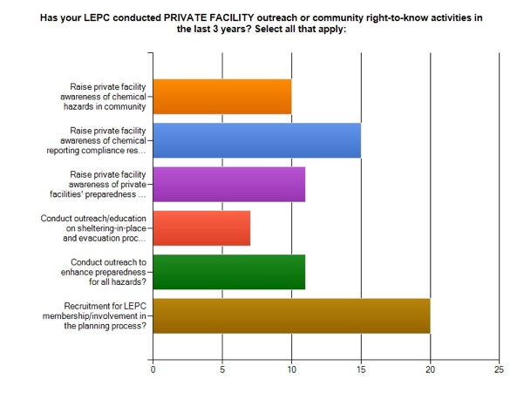
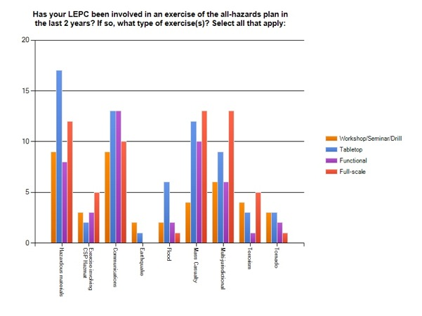
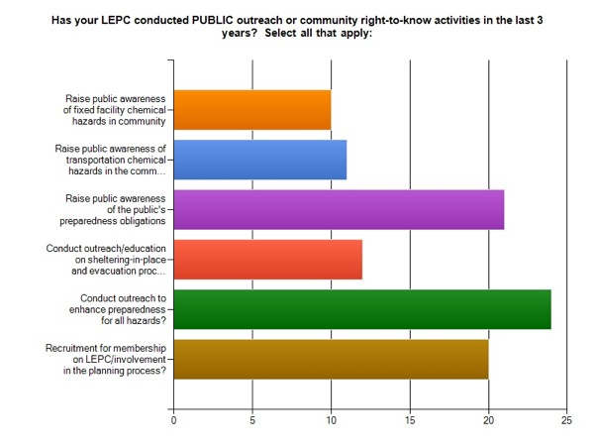
CEPC website
In 2010 the Commission created a website to serve as a resource to LEPCs and businesses as well as to provide information to citizens. The website is regularly updated with information regarding the work of the CEPC as well as providing additional resources such as Regional EPA newsletters, contacts for LEPCs and upcoming conference information. The website can be found at: http://www.coloradoepc.org/

Goals and Mission
At the end of 2011 the Commission began the drafting of a Goals and Mission paper. These initiatives as agreed to by the Commission include:
- Educate and encourage LEPC’s to create and/or participate in broad-based community planning and preparedness programs using their resources under EPCRA to identify, assess, and plan for hazards related to hazardous materials use, storage and transportation.
- Work with and encourage applicable agencies of State government and the All Hazards Regions to recognize and utilize LEPC’s in their work consistent with the Executive Order.
- Facilitate greater participation by nonprofits and the private sector in emergency planning and management activities at the community level.

Commission Meetings
Commission meeting are generally held on the 3rd Wednesday of alternating months. For the 2012 calendar year we will be conducting two outreach activities in place of regular meetings, one on the western slope and one in the southwest part of the state. The meeting dates through the end of the year:
- March 21, 2012
- May 16, 2012 in Grand Junction
- July 11, 2012
- September 12, 2012 tentatively scheduled to take place in the San Luis Valley
- November 14, 2012
Unless otherwise noted, meetings will be held from 1:00pm - 4:00pm at the Colorado Division of Emergency Management, 9195 E. Mineral Ave., 2nd floor Policy Room, Centennial, CO 80112
Agendas can be found on the CEPC website along with call-in instructions.

The commission continues to work on the following additional initiatives:
- Collaborating with the Colorado State Patrol Hazardous Materials Working Group to ensure consistency in planning efforts.
- Creation of a State-wide map which reflects the locations of hazardous materials facilities and transportation systems. The map which was originally created in 2010 is being reproduced in an alternate format to better allow for LEPCs to access and update their specific jurisdictional data.

Hazardous Materials Spill Data
The Office of Emergency Preparedness and Response at the Colorado Department of Public Health and Environment (CDPHE) has developed and maintains the only statewide environmental spill-reporting/tracking database, on behalf of the Colorado Emergency Planning Commission under the auspices of the Emergency Planning and Community Right-to-Know Act/Superfund Amendments and Reauthorization Act Title III (EPCRA/SARA Title III). The database was established in 1990 and is used to compile information concerning all environmental spills or releases that occur throughout the state and are reported to the CDPHE.

The Colorado Emergency and Incident Reporting Line received approximately 1,256 telephone inquiries from January 1-December 31, 2011. Eight hundred twenty seven (827) of those notifications called for a spill report to be generated, Three hundred fifty eight (358) additional phone notifications occurred after normal business hours (nights, weekends and holidays).

