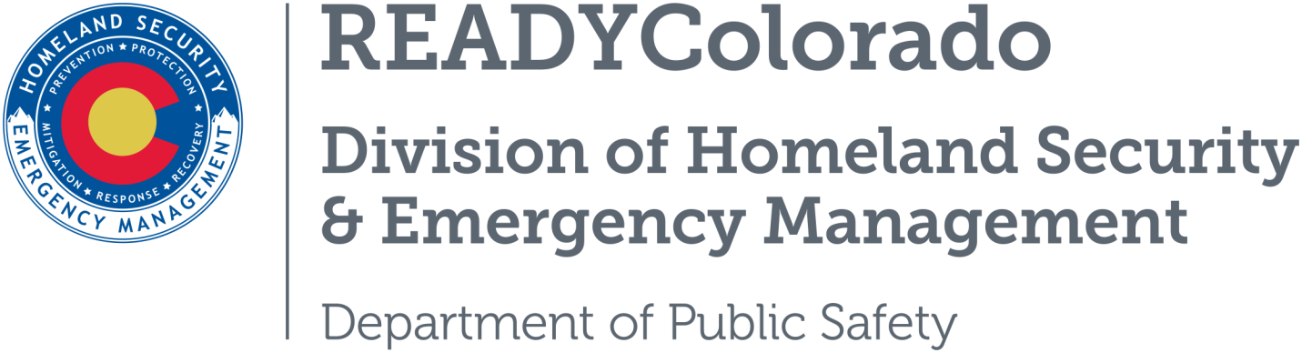
Spread the word with daily online safety and preparedness tips on Google+, Facebook and Twitter. Use the following blog, or create your own, and post all throughout the month. Remember to include the hashtags #COReady and #DrugFacts

Title: National Drug Facts Week: National Drug Abuse Fact Week Strives to Dispel Myths
About a third of high school seniors report using an illicit drug sometime in the past year. More than five percent report nonmedical use of potentially addictive prescription painkillers. More than twenty percent report smoking marijuana and thirty-five percent admit to using alcohol in the past month. Many teens are not aware of the risks to their health, to their success in school and the dangers while driving under the influence. When teens are given the scientific facts about drugs, they can be better prepared to make good decisions for themselves and they can share this information with others.
The Fifth Annual National Institute on Drug Abuse National Drug Facts Week takes place from January 23-29, 2017 and is the perfect opportunity to learn more and help shatter the myths about drug use for teens.
A drug is any chemical substance that can change how your body and mind work. Drugs of abuse are substances that people use to get high and change how they feel. They may be illegal drugs like pot, cocaine, or heroin. Or they may be legal for adults only, like alcohol and tobacco.
Medicines that treat illness can also become drugs of abuse when people take them to get high not because they're sick and following their doctor's orders. People can even abuse cough or cold medicines from the store if they ignore the directions and take too much at one time.

People Abuse Drugs for Many Reasons
- They want to feel good. Taking a drug can feel really good for a short time. People keep taking them to have those good feelings again and again. But even though someone may take more and more of a drug, the good feelings don't last. Soon the person is taking the drug just to keep from feeling bad.
- They want to stop feeling bad. Some people who feel very worried, afraid or sad abuse drugs to try to stop feeling so awful. This doesn't really help their problems and can lead to addiction, which can make them feel much worse.
- They want to do well in school or at work. Some people who want to get good grades, get a better job, or earn more money might think drugs will give them more energy, keep them awake, or make them think faster. But it usually doesn't work, may put their health at risk, and may lead to addiction.

Wondering how you can Take Part in NDFW?
There are plenty of ways to get involved:
- Participate in the 10th Annual “Drug Facts Chat Day” on January 26, 2017.
- Host a local event in your community ─ don’t forget to register it online
- Distribute the “Drugs: Shatter the Myths” booklet, and other resources, to teens
- Partner with the National Institute of Drug Abuse
- For more ideas and the latest news, visit the National Drug Facts Week website.

Information Source
- National Institute on Drug Awareness
For more tips and preparedness information, follow us:
On Twitter: @READYColorado
Facebook: www.Facebook.com/READYColorado
Google +: READYColorado
YouTube: www.YouTube.com/READYColorado

