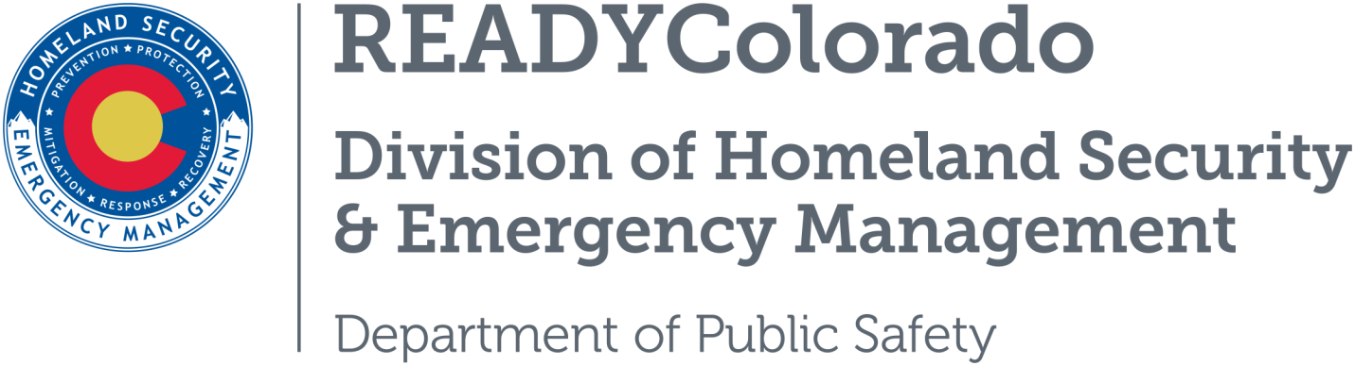
Spread the word with daily online safety and preparedness tips on Google+, Facebook and Twitter. Use the following blog, or create your own, and post all throughout the month. Remember to include the hashtags #COReady #NCSAM #CyberAware

Today’s Predictions for Tomorrow’s Internet
This week National Cybersecurity Awareness Month (NCSAM) explores smart cities, connected devices, digitized records, smart cars and smart homes which have become our new reality.
Could your refrigerator be putting your home network at risk? We live in a world of “smart” objects, where some things like thermostats, coffee pots, and refrigerators are connected to the Internet. We carry around smart devices like phones, wear them in the form of fitness trackers and medical devices and have personal digital assistants at home to give us the latest news, play our favorite songs or turn the lights on and off. This complicated Internet ecosystem offers us tremendous benefits, but it also poses unique risks.
Americans are constantly connected, making it important to understand how to use these cutting-edge technologies in safe and secure ways. These new devices pose various privacy and security challenges because they collect personal information which could potentially be accessed by others. Each person is responsible for understanding what information these devices collect and how it is being shared.

Tips to Stay Safe with New Technology
It is important to remind citizens that their sensitive, personal information is the fuel that makes smart devices work. Maintaining the security of this information is the responsibility of both the users and the device makers. Follow the simple tips below to secure any object or device that connects to the Internet and sends or receives data automatically:
- Read privacy policies and know what information a mobile application or device will collect to determine if you really want to share such information.
- Keep any device that connects to the Internet free from viruses and malware by updating the software regularly.
- Understand privacy settings to control how much information a device or app will display publicly about you.
- Set strong passwords and change them regularly.
While there are tremendous benefits of this new and evolving technology, it is critical to understand there are potential risks to using them as well. As a partner in the Department of Homeland Security’s cybersecurity awareness campaign, READYColorado and the Colorado Division of Homeland Security and Emergency Management are doing our part to make the Internet safer for everyone by participating in NCSAM. Learn more about NCSAM 2017 and how you can be cyber safe at https://www.dhs.gov/ncsam

Resources
- Department of Homeland Security
- Stop.Think.Connect
For more tips and preparedness information, follow us:
On Twitter: @READYColorado
Facebook: www.Facebook.com/READYColorado
Google +: READYColorado
YouTube: www.youtube.com/READYColorado

