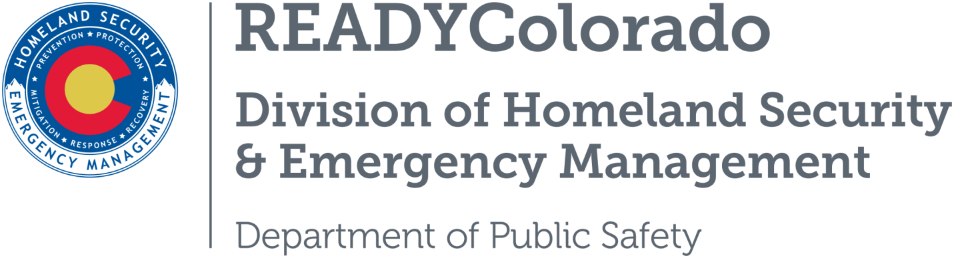
Spread the word with daily online safety and preparedness tips on Google+, Facebook and Twitter. Use the following blog, or create your own, and post all throughout the month. Remember to include the hashtags #COReady #NCSAM #CyberAware

The Internet Wants You: Consider a Career in Cybersecurity
According to a study by the Center for Cyber Safety and Education, by 2022, there will be a shortage of 1.8 million information security workers. It is critical that today’s students graduate ready to enter the workforce to fill the vast number of available cybersecurity positions. Week four of National Cybersecurity Awareness Month (NCSAM) focuses on encouraging students and other job seekers to explore cybersecurity careers. Key influencers – like parents, teachers, guidance counselors and state and local officials can all help engage youth in pursuing cybersecurity careers.

Is Cybersecurity Right for You?
Cybercrime is now the number one threat to United States national security. As the number of large-scale data breaches and cyberattacks continue to rise year after year, there is an increasing need for educated and dedicated cyber professionals to protect our Nation, businesses, and individuals from cyber threats. According to the National Initiative for Cybersecurity Careers and Studies (NICCS), there are over 200 top colleges and universities across 44 states that are designated as Centers of Academic Excellence (CAE) for cyber-related degree programs. CAE graduates help protect national security information systems, commercial networks, and critical information infrastructure in the private and public sectors.

Do you know someone in your life who might be interested in a career in cyber? Someone who:
- Likes to see how things work, such as taking apart toys and electronics
- Enjoys looking at a problem from new angles and finding a different kind of solution
- Is enthusiastic and can adapt to an evolving subject matter

If so, you can direct this person to learn more about cybersecurity careers and studies at www.niccs.us-cert.gov.

The internet today has become an invaluable resource in both our personal and professional lives. We have access to more information than ever and that means there is a need for more trained professionals to help safeguard that information.
Our nation needs more cybersecurity professionals to protect networks in both government and industry. Nearly one in five Americans has been the victim of a cybercrime and the economic impact of these attacks is devastating. Cyberattacks cost the average U.S. Company more than $15.4 million per year. Cybersecurity professionals work every day to increase awareness and make the Internet safer and more secure for everyone. They help innovate and communicate approaches and strategies for businesses and the public to keep themselves, their families and all communities safer online.

Resources
- National Initiative for Cybersecurity Careers and Studies (NICCS)
- Department of Homeland Security
- Stop.Think.Connect
For more tips and preparedness information, follow us:
On Twitter: @READYColorado
Facebook: www.Facebook.com/READYColorado
Google +: READYColorado
YouTube: www.youtube.com/READYColorado

